What Is Feature Scaling In Machine Learning:
- a machine learning pre-processing step that transforms numerical features to a common scale, ensuring no single feature dominates the model due to its larger magnitude
- Common techniques:
1. normalization (scaling to a range like 0 to 1)

2. standardization (scaling to a mean of 0 and a standard deviation of 1)

- This is critical for algorithms like gradient-based models and distance-based algorithms,
- Because of scaling each input feature contribute equally to the output feature
Why feature scaling is important
- Prevents feature dominance:
Features with larger ranges, like income in thousands, can outweigh features with smaller ranges, such as age, in distance-based or gradient-based algorithms.
- Improves algorithm performance:
Algorithms like logistic regression, neural networks, and K-Nearest Neighbors are sensitive to the scale of input features and perform better with scaled data.
- Speeds up convergence:
For algorithms that use gradient descent, feature scaling can lead to faster convergence to a solution.

How feature scaling affect different ML models

Gradient Descent Based Algorithms
Machine learning algorithms like linear regression, logistic regression, neural network, PCA (principal component analysis), etc., that use gradient descent as an optimization technique require data to be scaled. To ensure that the gradient descent moves smoothly towards the minima and that the steps for gradient descent are updated at the same rate for all the features, we scale the data before feeding it to the model.

Distance-Based Algorithms
Distance algorithms like KNN, K-means clustering, and SVM(support vector machines) are most affected by the range of features. This is because, behind the scenes, they are using distances between data points to determine their similarity.

Tree-Based Algorithms
Tree-based algorithms, on the other hand, are fairly insensitive to the scale of the features. So they don’t need feature scaling

NORMALISATION | STANDARDIZATION
Min max scaler is used | Standard scaler is used
All the feature values are scaled strictly between 0 to 1 | All the feature values are scaled in such way that the distribution will have mean 0 and standard deviation of 1 ( the rescaled values are less than 0 or greater than 1 also)
Useful when the distribution of the data is unknown or not Gaussian | Useful when the distribution of the data is Gaussian or unknown
Retains the shape of the original distribution | Changes the shape of the original distribution
Sensitive to outliers | Less sensitive to outliers
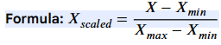 | 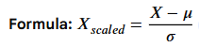  - = is the mean of the feature values  = is the standard deviation of the feature values

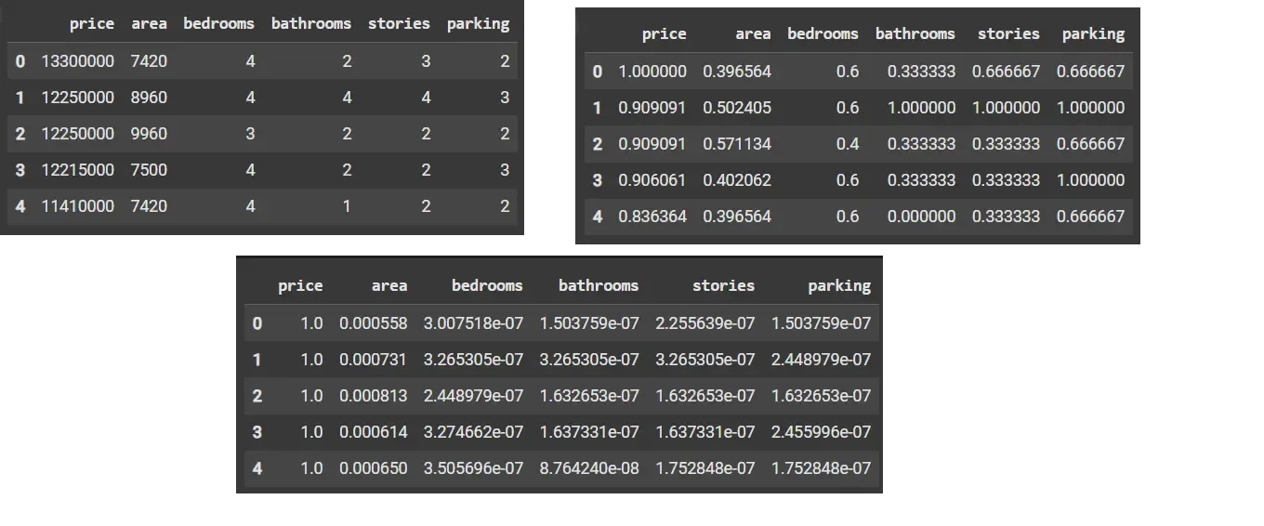

Feature Importance in Machine Learning (ML)
Feature importance tells you which input features contribute the most to a model’s predictions.
It helps you understand:
- Which features are useful
- Which features can be removed
- Which features drive model decisions (explainability)
- How to improve model performance
Feature importance = score that shows how much each feature affects the prediction.

